Guide Vertical (all streams) Skills Currency
Performance Check

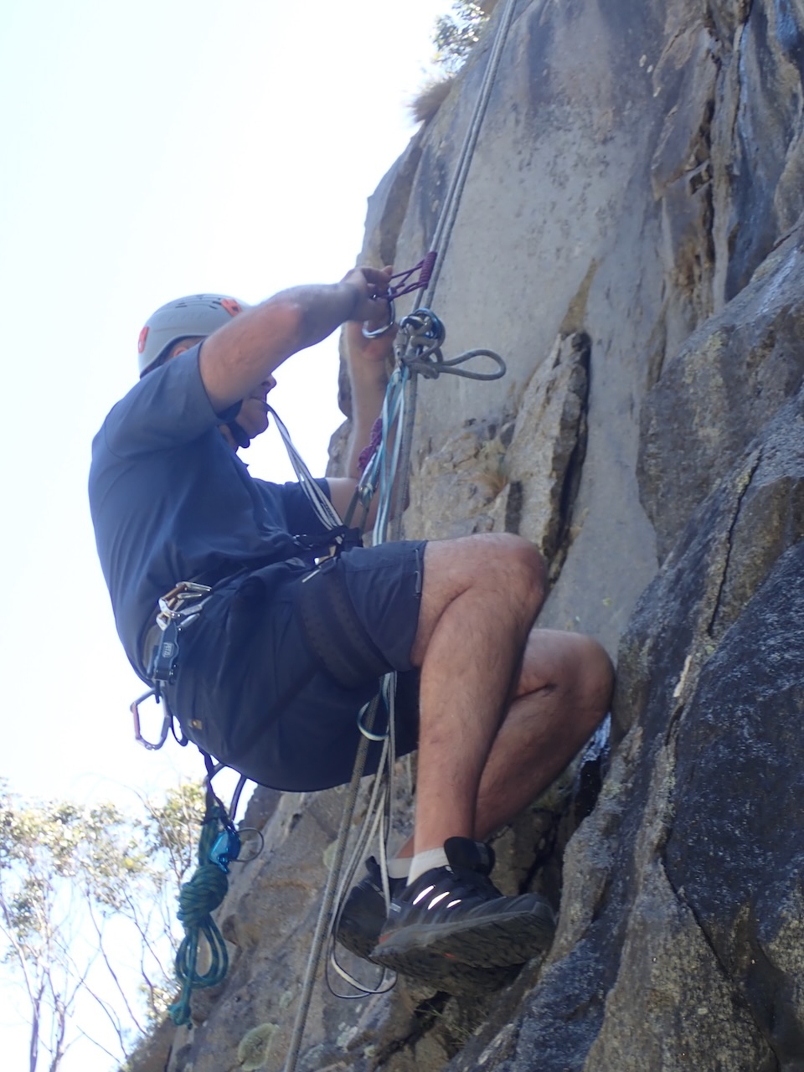

Name: |  | Scout Membership No:
Formation

Introduction
This document sets out the performance requirements to demonstrate skills currency for a Scouts NSW Guide in Vertical Streams. In addition to these performance requirements opportunities for further training and development may be provided.
Please remember to capture photographs. Once all of the items in the skills performance requirements are completed please lodge this document via the following link insert link here . After lodgement of this document and photos, a review will be undertaken and once completed your continuation as an appointed Guide Vertical will be recognised with Scouts NSW.

Skills Currency Performance Check Items
The following items will be completed while you are a skills currency performance workshop. Please make sure the below check list is completed and is signed by your Workshop Leader.
Activity |  |  |  | Competency Achieved
Please answer the following questions or demonstrate the following skills
- Demonstrate ability to assess the situation, identify hazards promptly, assess risk and manage to avoid injury to self and others
- List the site specific hazards identified and the information to be included in your participant briefing to manage these:
Hazard |  |  | Briefing Information
Falls from height
Slips and trips
Falling rocks and debris
Heat related illness
Descender entanglements
- Outline your vertical Rescue Plan (when practiced) including any WHS

- Select and inspect anchors, rig rope systems suitable for single pitch abseils using different systems (eg/ MMO, Gigi, Figure 8 block) and anchor types (eg/ fix artificial, naturally occurring)
Anchor Type | Rigging Method | Belay Method
- Tree
- Bolts/hooks
- Eye/Ring
- Rig suitable top rope belay system
- Complete simulated arrest of a falling abseiler, and safely and efficiently secure and release abseiler to continue (includes demonstrating understanding of weight differentials and how this affects the arrest)
- Complete self rescue – abseil descent, bypass a knot, continue to abseil, change over to another system, ascend rope, change over from ascending to descending (Should be completed in under 15 mins)
- Demonstrate ability to determine appropriate rescue methods and techniques taking into account the needs of the person being rescued and the ratings of equipment being used.
- Perform a non-contact rescue of a conscious person – lowering rescuee, passing a knot for a joined rope though the system. (Should be completed in under 5 mins)
- Perform a non-contact rescue of a conscious person – raising rescuee (Should be completed in under 10 mins)
- Designate roles and responsibilities to team members and participants to effectively complete rescues
- Participate in debrief and complete incident report in accordance with organisational procedures.
- Perform an escape from belay (when trapped in system)
Photo Taken
Have a photo(s) of you rigging different mechanical advantage systems and releasable abseil lines using different types of anchors (fixed artificial, naturally occurring and artificial removable) and attach.
Have someone take a photo of you performing self rescue change overs (ascent to descent, descent to ascent and bypassing a knot) and attach.
Have someone take photo of you performing a haul of a conscious person using a mechanical advantage system
Log Book
Present logbook and submit with this form. (Note) Logbook must show direct participation in the vertical activity. eg/ caving – must have actually been inside the cave, canyoning – must have actually been in the canyon).

The candidate demonstrated currency in vertical skills and is competent to continue their appointment as a Guide Vertical.

On Program Leader Name:

Signature: Date: …../ /....

Supervisor Initials
Please ensure that all Supervisors who put initials above put their names here so they can be verified by the “On Program Leader.”
Name | Initial

Post Program Evidence Items (document in your logbook and don’t forget to include photos)
The following items need to be completed to complete your Program Pathway
- Log your abseiling activities.

Notes for Workshop Leaders (Appointed Supervisors)
The following are notes to the skills performance check process:
- It is suggested that participants should be assessed at an area they would not usually operate at. The unfamiliarity will ensure that candidates can apply their skills in a range of areas and assess sites and the risks associated with different sites.
- Candidates should be able to consistently demonstrate ability to manage edge safety and ensure appropriate connection, should be able to identify hazards of site and controls to be conveyed to participants.
- PE5. Arresting falling abseiler – This would be simulated on a top rope belay and the candidate should be surprised by it and not prewarned.
- PE6. Self Rescue – Candidate should be able to complete this item in under 15 mins to be deemed competent.
- PE8. Lowering a stuck abseiler – This would be simulated and candidate should not be prewarned. Should be able to do this even with passing a knot for a joined rope though the system in under 5 mins to be deemed competent
- PE9. Raising a stuck abseiler – This would be simulated as a group and PE7 & PE10 would be included into this item. The candidates should be able to complete this item in under 10 mins to be deemed competent.
- Total session should be viewed as a training opportunity where feedback is given and open discussion about the pros and cons of setups, lowers, hauls etc occur such that increased knowledge and understanding occurs. This is professional development where we break down the systems that have been rigged by candidates, identify improvements, understand equipment limitations, understand issues that might arise, look at different ways of doing things, understand why we do certain things, understand why we don’t do certain things.

