Feeling Safe at North Coast Region Rally 2021

Feeling Safe – Your Rights – A message for our youth
Everyone in Scouts, youth and adults alike have the right to feel safe and be protected from abuse. No-one is allowed to threaten you, hurt you or touch you in a way that makes you feel uncomfortable, unsafe or afraid.
A Scout is respectful, and this applies to all interactions between all participants, youth and adults here at Region Rally.
You do not have to deal with abuse on your own.
If you feel unsafe, threatened or you see/hear something that causes you concern, please speak to a Leader or Rovers on an activity. Your concerns will be taken seriously. The information you provide will be shared with people who can support and protect you.
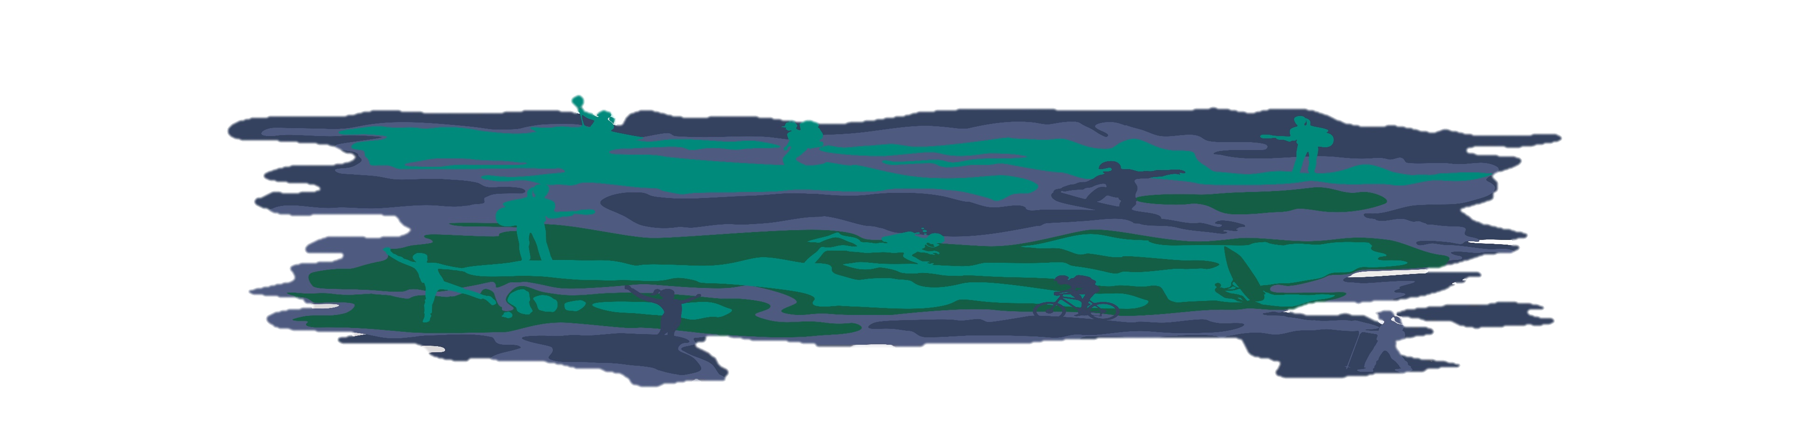
If you don’t know what to do – speak to someone at Region Rally HQ. If, for any reason, you do not feel the concerns of this nature which you raised at Region Rally have been satisfactorily dealt with, please report your concerns directly to the Child Protection Team at the NSW State Office on Tel: 02 9735 9000 or via ChildProtection@nsw.scouts.com.au or your parents.

