Alpine Preparation
Your introduction to the skills required to enjoy winter hiking, Cross Country Skiing and Back Country Skiing. The training you need for short trips into the Australian alpine environment can be gained by attending all 4 of the Hunter Scout Region’s Alpine series of courses.
  - The Alpine Series of Courses
Alpine Preparation – Usually 2nd Saturday in May. It is a 1 day course to prepare you for the change from winter bushwalking to alpine walking and skiing.
Alpine Walking – Usually 2nd weekend in June. It is a short 2 day hike in the Barrington Tops to test you and your gear in cold, wet conditions. During the weekend we will also; improve your navigation skills, talk in detail about the different types of tents used on the trip, and put into practice everything you’ve learned on the Alpine Preparation course.
Cross Country Skiing – Usually 2nd weekend in July. A weekend introduction to skiing on Cross Country skis. We generally stay in relative comfort at a caravan park (hot showers, camp kitchen, common area with fire)
Back Country Skiing – Usually the 2nd weekend in August. This is the highlight of the year. Just you, your pack, your skis and you set off into the wilderness for an overnight camp.
  - Badge work
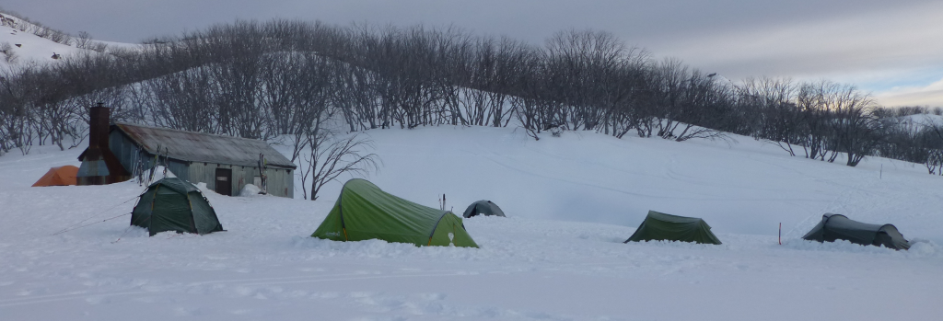
If you are interested in doing badgework then the Alpine series of activities is a great way to go towards your OAS Alpine Stage 1 to 5.
Planning and Emergencies
“In the case of an accident you need to apply your first aid training. But most emergencies can be avoided by good planning and preparation.”
Many emergency situations are actually the result of insufficient planning and preparation, not the final accident that may have occurred. If you do not have the correct equipment, training, or experience then you have not prepared properly. If you have not given yourself enough time (time to complete the activity, time for sleep and rest), or do not have the resources you need (clothing food, water, fuel) you have not planned adequately.
When preparing for Cross Country Skiing we must prepare for everything we can, as we are going into a hostile environment – very cold and potentially wet. Hypothermia is avoidable, but you must prepare yourself properly. You need to have appropriate clothing, shelter, bedding, fuel, and food ... ... but that is not all! You also need to have training in staying warm and dry, and you need to gain experience in cold environments to prepare yourself for living in the snow.
  - Preparing yourself for Cross Country Skiing & a Skiing trip
You need to know all the tip and trick of how to keep yourself warm and dry in a cold and wet environment. Things like:
- How to keep dry when your tent floor is wet and 0º Celsius,
- How to get you gas fuel to burn when it is so cold,
- What clothes will dry and which will not (NO Cotton), and
- Which tents will work when it is snowing, and which ones don’t?
Like all adventurous activities, planning needs to be thorough, and needs to cover all the pre-trip tasks. Tasks such as:
- How am I going to get to the snow and how am I going to do that safely?
- Is all my equipment in good working order?
- What weather is forecast, and should I still go?
- Have I trained adequately?
- How much time do I need for each part of the activity?
- What contingency plans do we have, and contingencies equipment do we need?
  - Emergencies
Ideally there are no emergencies, but we need to be prepared for one should it occur. Emergency beacons will be carried in case of emergency. Many Venturers will have basic First Aid training as part of their Venturers Skills. Make sure you read Hypothermia section of the Snow Safe pocket guide (http://snowsafe.org.au/schoolclub-information/ to download the guide, for just the hypothermia section
http://snowsafe.org.au/hypothermia-prevention-recognition-and-treatment/). This has good information on Hypothermia identification and treatment.

HYPOTHERMIA
Hypothermia is a lowering of the body’s core temperature, which can result in death, and can occur as a result of:
- Accidental immersion in cold water.
- Inadequate protection from the cold environment, especially when combined with altitude, wind, moisture and physical exhaustion.
- Exposure to cold, especially in the unconscious, the elderly, young children and the injured.
PREVENTION
Hypothermia is easy to prevent. When it occurs it is usually from lack of preventive action rather than unavoidable circumstances. These simple measures will prevent the likelihood of hypothermia:
- Adequate protection from cold, wind and moisture. Wear appropriate clothing, stay dry and beware of wind.
- Regular intake of food and non-alcoholic drinks. Eat appropriate energy food such as fruit or warm sweet fluids, if available, and drink regularly.
- Sound planning, training and experienced leadership. Always carry a large plastic bin liner bag in your daypack as a precaution.
RECOGNITION
Know how to recognise the signs of hypothermia. If hypothermia is apparent, stop immediately and seek shelter.
- One or more of the following signs should alert others to the onset of hypothermia:
- Stumbling.
- Careless about protecting against the cold.
- Shivering.
- Unusual or irrational behaviour.
- Poor judgement.
- Displays apathy, ie lacks interest.
- Exhaustion.
- Slurred speech.
- The person feels cold to touch and is unusually pale.
HYPOTHERMIA TREATMENT
The basic principles of first aid and resuscitation apply, plus additional specific measures to stop further body cooling. If any member of the party develops the signs of hypothermia:
- Stop immediately.
- Protect casualty from wind and moisture – find or improvise shelter.
- Put on extra layers of clothing, remembering to cover the head and put on wind/water proof jacket and overpants.
- Insulate the body from the snow, especially the head.
- Prevent further heat loss by covering the casualty with any available waterproof material.
- Huddle together.
- Give easily digested food and drink, warm if possible.
- Ensure all party members put on extra clothing, including head cover.
- Send for medical assistance.
SEEK MEDICAL ASSISTANCE IMMEDIATELY, PROVIDING YOU ARE NOT ENDANGERING YOURSELF OR OTHER PARTY MEMBERS
For ambulance, police and fire emergencies, call ‘000’ or contact your local ski patrol.
PREVENT EMERGENCY SITUATIONS
Emergencies are often the result of poor planning and/or foolhardy behaviour. If you do find yourself in difficulties, stop and think. Knowledge of your own capabilities is an important safety factor. Individual skills and fitness levels vary greatly. What is quite safe for one person to attempt may be foolhardy for someone else.
TREATING A CONSCIOUS PERSON WITH HYPOTHERMIA
- Carefully lay the casualty down.
- Protect from the cold environment and prevent any further heat loss by placing insulating material under the person – use packs, jackets, mats, bags – whatever you can find.
- If a large plastic bin liner or garbage bag is available, place the casualty feet first into the bag, ensuring that the body and neck are enclosed. Arms and hands should not be covered by the bag. (The casualty may have to be placed in the coma position.) Do not cover the head or face with the bag.
- Cover with a blanket or sleeping bag and ensure the head and neck are covered with a beanie, jumper or fibre pile jacket, leaving the mouth, nose and eyes visible.
IMPORTANT
- Do not give alcohol, cigarettes, strong coffee, or tea.
- Do not attempt to stimulate the peripheral circulation by rubbing or massaging the extremities.
- Do not expose the patient to hot air or direct radiant heat from a fire. The application of external heat could worsen the person’s condition.
TREATING AN UNCONSCIOUS PERSON WITH HYPOTHERMIA
- An unconscious person must be handled with extreme care.
- Minimise unnecessary movement.
- Do not give any food or drink to an unconscious person.
- Signs of life may be minimal but continue treatment until help arrives.
- Provide the normal care of airway, breathing and circulation.
- With the person in the lateral or coma position, prevent further heat loss by insulating, and protecting from the cold environment.
- If adequate insulation and a warm shelter are available, gently remove the outer wet layers (it may be necessary to cut clothing to aid removal), dry off, replace with layers of dry clothing and insulate.
- If shelter is not ideal, leave wet clothing on, add extra layers of clothing over the existing wet ones and cover with any available waterproof material. Wrap casualty in a sleeping bag or blanket to prevent further heat loss. If a large plastic bin liner or garbage bag is available, place the casualty feet first into the bag, ensuring that the body and neck are enclosed. Arms and hands should not be covered by the bag. Do not cover the head or face with the bag.
- If medical care is not available, the rescuer should ensure extra body warmth is provided by placing a companion on either side and close to the casualty. Ensure all are insulated from the ground, preferably in sleeping bags.
- Use caution in applying external chemical heat sources or hot water bottles, never apply these directly to the skin.

Alpine Activities & the Environment
  - Australian Alps: Unique cold climate plants and animals
  - The Mountain Pygmy-possum; Burramys parvus, is Australia’s only hibernating marsupial. There are thoughts to be less than 2,000 Mountain-Pygmy-possums left in the wild, the species is listed as Critically Endangered; eg. In 2007, only 60 females found at Mt. Blue Cow. Mouse sized, prehensile tail, nocturnal, marsupial, lives in rock-screes and boulder fields at elevation 1,300 m to 2,230 m. Eats Bogon moths, fruit, nuts, nectar and seeds. Main threats are habitat destructions (construction of ski fields and roads which block migration of males) and predation by cats, foxes and threats to Bogon moths.
  - Bogon Moths. Mass migrate in late spring/summer to rock crevices in alpine areas where they remain inactive. Fly up to 1,000 km during their migration! They return north to breed; one female can lay 2,000 eggs. In winter the caterpillars, known as cutworms because they cut through stems of plants at ground level, feed on plants from southern Qld to SA. They are an agricultural pests and thousands are killed by pesticides. Concern about levels of arsenic accumulation in bodies of surviving adults.
  - Snow gums. Eucalyptus pauciflora. Mostly smooth bark with white, grey and brown-red mottling. Leaves have distinct parallel veins. Mass of white flowers in the spring and summer. Occurs 1,300 m – 1,800 m where they form the tree line. Lowland stands have been mostly cleared and now big effort in preserving remnants. It’s been introduced to Norway!
- Large annual Aboriginal gatherings based on bogon moth feasting, which they cooked. Tastes nutty. Last known one was in 1865.
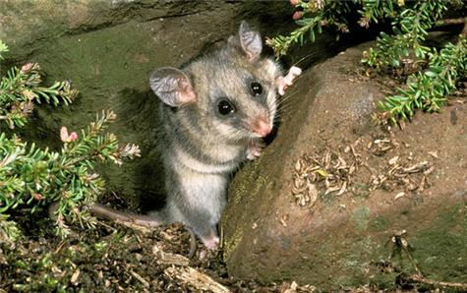
- Pioneer history since 1830’s – Introduction of feral horses and pigs which damage fragile sub-alpine plants; bogs and streams.
  - Reducing our impact while visiting/skiing
- Fires/fire wood – Only use dead, fallen wood; standing dead trees provide shelter for many animals (so do fallen wood). Make sure extinguished before leaving site.
- Skiing off-piste – Limit this at it compacts the snow, where space between the shrubs, rocks and boulders and the snow (call sub-nivean) where small animals seek shelter or travel searching of food. The soft snow acts like a blanket trapping small pockets of air.
- Protection of water sources - Wash dishes at least 50 m away from stream. If using bush toilet; go at least 100m from any waterway. For solid faeces; dig a hole into the soil with trowel approx 15 cm deep; otherwise, if left above the soil, your contribution will still be there in spring when the snow melts! Toilet paper and other sanitary items to be carried out. Toilet paper can be put in the toilets of out -houses, but other items must be carried out.

Clothing & Equipment
  - Survival
- First Aid Kit (plus the skills and knowledge to provide first aid)
- Map & Compass (plus the skills and knowledge to use them)
- Food & Water (plus 2 extra days of food in case you get trapped by bad weather)
- Whistle
- Wet weather gear
- Emergency Shelter (your tent will be OK for this)
- Torch, Matches/Lighter, Pocket knife
- PPE
- Snow shovel and Personal Locator Beacon (PLB) – 1 per group
  - PPE (Personal Protective Equipment)
- Boots (waterproof), socks (woollen)
- Clothes (layers)
  - 1 x wicking - Polypropolene (usually) or sometimes wool
  - Many x warmth - Polar fleece
  - 1 x outer shell - Waterproof/ windproof shell – generally need top and bottom
- Products (Suncream, insect repellent, chapstick)
- Beanie / hat / Balaclava / Buff
- Sunglasses & Goggles
- Gloves / Mitts
  - Necessities (to make your trip more comfortable)
- Backpack & a method to waterproof all the gear contained in it
- Sleeping bags – Advantages & disadvantages of main types
- Sleeping mats are definitely required - Closed cell foam, self inflating
- Cooking equipment (stoves: hexi, gas, metho)
- Trowel & toilet paper
- Spare clothes
- Gaiters
- Small towel or chamois
  - What NOT to bring
- No cotton! Cotton wicks heat away from the body when wet. So no jeans!
- Resort ski gear is generally bulky and you tend to overheat with this gear.
  - Optional
- Technology (GPS, Mobile phone, walkie talkies, camera, go pro, ....)
- Pack of cards / games

Navigation
  - Map
- Aerial view
- Topographical maps used for scout activities
- Grid lines
- Contour lines
- Legend (what the markings mean)
- Important info (when produced, which grid systems, North(s), ....)
- ARE NEVER ACCURATE
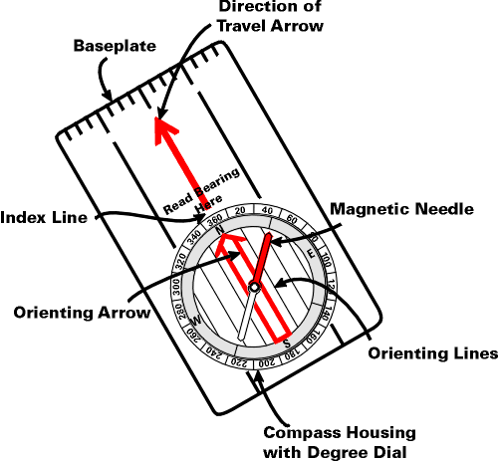
- Old maps use different Grid system – may need to change GPS unit
  - Compass
- Directional device
- Base plate compass with 360 degree markings is best for our purposes
- Bearings
  - Hold compass in front of you
  - Point direction of travel arrow toward the object you are taking a bearing to
  - Rotate Housing until orientating lines are parallel with Compass Needle
  - Read Degrees from Housing
- Converting Bearing (adjust for declination)
  - Compass to Map – Add
  - Map to Compass – Subtract
  - Declination varies according to where you are in the world – generally on the East Coast of Australia it’s around 12 degrees
  - Contours

  - Important Map Features you should know
- Ridge, Spur, Cliff, Saddle
- Gully, Creek, River
- Roads, buildings, man made

Alpine Hiking/Skiing Food & Cooking
Cross Country Skiing requires a lot of energy. In fact, it is one of the most vigorous sports you can do! When cross country skiing, you exercise using both the upper and lower body. The combination of colder temperatures, carrying a backpack and climbing mountains means that you will burn more energy, and so need to pack more food than you would normally pack for a bushwalk.
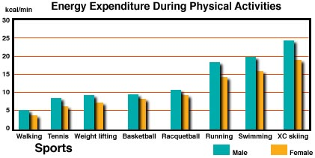
The level of exercise means you will also need to be careful of dehydration. Because it is cold, you might not feel like drinking much, especially cold water. Be aware of the signs of dehydration – dry mouth / thirsty / headache / decrease in or concentrated urine.
The need for warm foods is also greater in the snow than anywhere else. Packing easy-to-make warm drinks and soups mean that it is easier to get warmed up, rehydrated, and get some energy back after an exhausting day of skiing. It can even be a good idea to have some warm drink in a thermos to warm you up and keep hydrated while you are out on the track.
Food Options
Always aim for a healthy-balanced diet. Pack a broad range of food types. Just because you are heading ‘bush’ does not mean you have to eat rubbish food. Sustagen for breakfast and two minute noodles for dinner IS NOT a balanced diet! Aim for ‘Alpine’ Master Chef. Multiple Courses at dinner will ensure you are putting enough energy in to keep you going tomorrow. Think about a quick soup when you first arrive at camp, then your main course, followed by a dessert, then a hot chocolate with more chocolate to finish off….
Heading into a cold environment has some catering up sides: Its cold, so you can take things that may not last a summer bushwalk, and there’s a big fridge just outside your tent/hut: so try some fancy desserts that need to set in the fridge. Look in the supermarket for powdered instant puddings, jellies etc. which can be readily chilled. In all but very challenging conditions, cooking something nice is readily possible with just a little planning/forethought. Try it at home first in the back yard with your hiking stove/cooking set. …Google for ideas.

Cooking equipment
You will find that your stove will use more fuel due to the cold and thinner atmosphere – remember you are warming water from zero degrees to 100, rather than from 20 degrees. You will also use MUCH more fuel if you melt snow. The energy required to melt snow from just below to just above freezing is almost as much as the energy to boil water from 0 to 100 degrees. Rather than carrying twice as much fuel, try to find a clean stream!
Some fuels work well at high temperatures, but not in the cold. The best gas canisters for snow camping use an IsoButane / Propane mix. IsoButane is a gas above -12 degrees, while Butane is a gas above 0.5 degrees. Propane is a gas above -42 degrees. This means that in low temperatures, the Butane will become a liquid, which results in poor stove performance. To keep your gas stove running well, put the canister in your sleeping bag or inside your jacket to warm it up. Metho Burners (Trangias) are reliable, but you will need much more fuel. If you are cooking on the snow, you will need some kind of board to help keep the fuel warm and stop your cooking surface from melting.
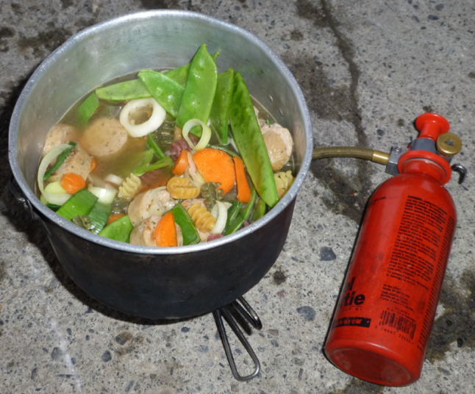
Matches / Lighters do not work when wet, and the snow is a moist environment. Pack matches in snap lock bags or small sealable plastic bottles (don’t forget to pack the flint from the side of the matchbox!)
Emergency Food
Because the weather can change quickly in alpine areas, it is always best to be prepared to be snowed in. It is best to pack at least 1 full day of extra food for each person. Make it as light and as easy to prepare as possible – you aren’t really planning on using it. This also becomes your “easy option” if cooking you “Alpine Master chef” recipe is impossible because of the weather.
Organisation
You will benefit weight wise if you share food and cooking equipment with someone else. This also means you share the cooking and cleaning responsibilities. Remember you will still need enough food/fuel for 2, you save weight by sharing stoves/pots.
In Cold/windy conditions, you want to pack things so that you can easily grab what you need. Make sure lunch and snacks are near the top of your pack, while dinners and breakfasts can be packed further down. Reduce bulk and weight by getting rid of packaging wherever possible, but double bag anything that could be messy if a bag splits. Keep a bag handy for rubbish.
Staying Healthy
As well as considering energy needs, the need for a balanced diet, and staying hydrated, it is important to practice a few hygiene practices to make sure you stay well. These include:
- ensuring your source of water is clean, and using water purification if you are in doubt.
- Using a hand sanitiser or washing hands after toileting (sanitiser is the warmer option)
- Ensuring tables in huts are clean before and after use. There are bush rats who live in the huts, and rat poo in your food is never a good thing.

Some Menu Ideas to Consider:
Breakfast
Cereal of your choice, with Powdered / UHT mik. Consider Warming up the milk
Rolled Oats / Powdered Milk / Brown Sugar / Dehydrated Fruit – makes a warm and filling porridge – Or you can buy them prepacked at the supermarket – expect to pay more
Bacon on breadrolls or Premade pikelets with jam / honey

Lunch / Snacks
Vita Wheat / Lebanese Bread / Mountain Bread
Cheese / Salami / Fresh Tomato (Pack in a small container so they don’t squash) / Sundried Tomato / fresh Spinach Leaves / Tuna / Salmon (Avoid bulky tins – try and get sachets)
Muesli Bars / Chocolate
Scroggin (Trail mix / jelly babies / dried fruit / m&ms)

Dinner / Dessert
Entrée:
Cup a soup, or Noodles
Main course:
Camp meals from a camping store – just add hot water and wait. Easy to prepare, but cost about $15
Pasta Sauces – Cost only a couple of dollars, then add in extras –salami, extra cheese, dehydrated peas and corn, mushrooms. The packets sometimes require butter and milk – I just use a bit of powdered milk and it works fine
Salmon in Chilli Sauce, stirred through pasta – add extra vegetables
pre-diced frozen (100g or so) fresh chicken/pork/ mince/bacon etc. ( bagged in a water tight hard plastic container ), with a few vegetables (pre-diced carrot, snow peas) and tomato paste/powder. cook with pasta or rice
Home dehydrated meals – prepare at home, then add hot water. Sometimes takes a while to rehydrate. Many modern ovens will work as dehydrators – Google to find out how, or talk to leaders.
Dessert:
Stew dehydrated fruit, and cover with crushed butternut cookies to make a fruit crumble
Cheesecake – powdered packs available at the supermarket – Cover and use snow to set
Jelly – Cover and use snow to set
Chocolate mousse – powdered packs at supermarket
Drinks: Tea/Coffee/Hot Chocolate (remember sugar and powdered milk)

